COMP 1805 B1

Michael Maxwell

101006277

MARCH 24, 2016

4

* 1. The degree of v2 is greater than the amount of vertices.

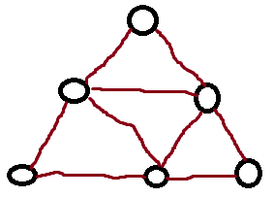

* 1. The degree of the graph is odd. Handshaking Lemma.

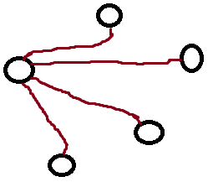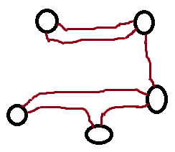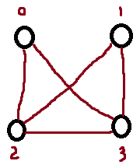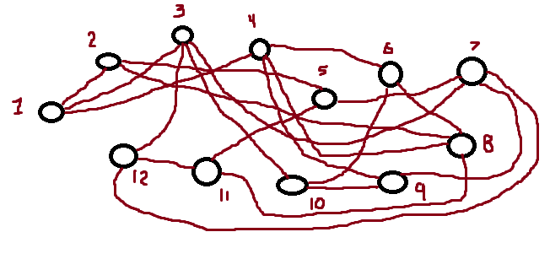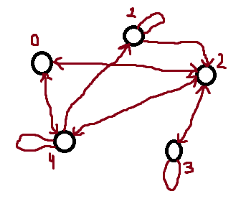

1. The numbers in the resulting matrix’s diagonal represent the number of bi-directional edges.  
   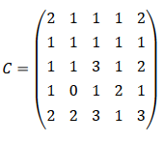
2. G = (V, E) is bipartite iff G can be coloured with 2 colours.  
   Let G be a bipartite graph with bipartition R, B.  
   Let S = {Red, Blue}   
   Define f (v) = {Red if v ∈ R, Blue if v ∈ B}   
   Suppose G is a 2-colourable graph and let f be a proper two colouring with colour classes R and B.  
   The f function makes sure there are no edges within R or within B. Therefore G is bipartite with 2 partitions R and B since R ∪ B ∈ V and R ∩ B ∈ Ø must be true.
3. A graph G with n ≥ 4 vertices, where n is even, if every vertex has degree n / 2 + 1, then G must contain a clique of size 3.
   1. Euler Path: G-F-C-G-B-C-H-D-E-A-H-I-D-A-I-B-F

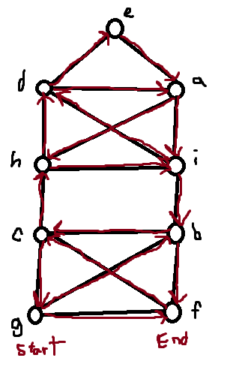

* 1. Euler Cycle: A-C-B-D-E-B-H-D-F-G-H-A-E-G-A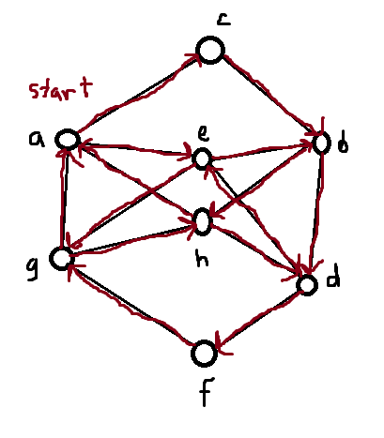
  2. There is more than 2 odd degree vertices, so there are no Euler cycles or paths.
  3. Euler Cycle: A-C-B-D-E-H-D-F-G-A-B-H-G-E-A

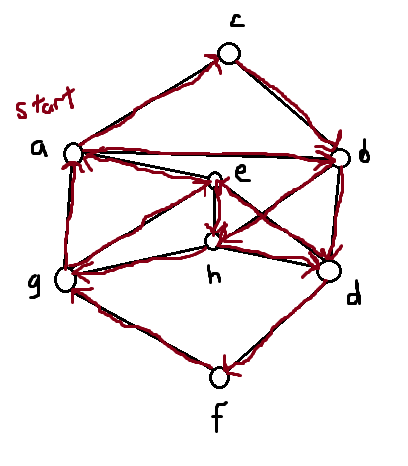

* 1. BFS Tree:

2 : 4, 6  
3 : 15  
4 : 14

7 : 2, 3, 10, 16

8 : 13

10 : 5

12 : 7, 8, 9, 11

13 : 1  
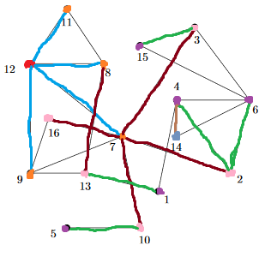

* 1. DFS Tree:  
     1 : 13  
     2 : 4  
     3 : 15  
     4 : 1, 6  
     6 : 3, 14  
     7 : 2, 10  
     8 : 11  
     9 : 16  
     10 : 5  
     12 : 7  
     13 : 8, 9

